Insert title

Insert subtitle

Insert image

*[The image below is an example image]*

sadkpoaf

*The*

**www.nvfnorden.org**

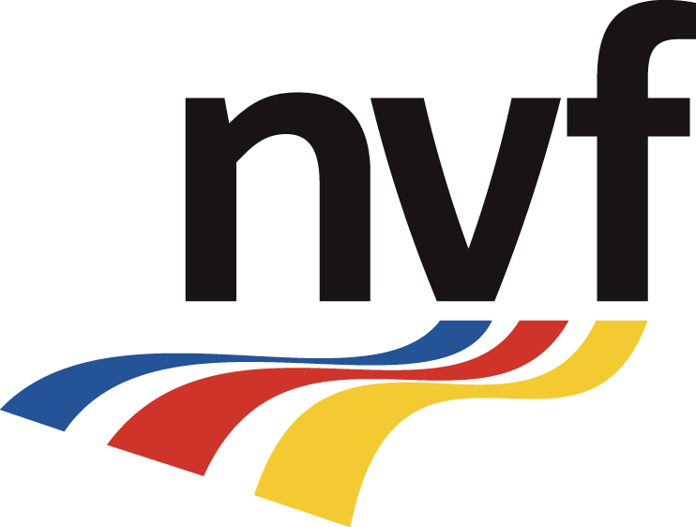



|  |  |  |
| --- | --- | --- |
| Working group | | **Date** |
| Name of the working group | | 24 July 2024 |
| Title | | **Pages** |
| Title of the report | | [insert number of pages] |
| Prepared by | | | |
| First name, Last name, Title, Company | First name, Last name, Title, Company | |
| Summary | | | |
| Write a summary of the report here. | | | |
| Outcome | | | |
| Describe the outcome of the work. | | | |

Table of contents

Heading 1 3

Heading 2 3

Heading 3 3

# Heading 1

Insert text

## Heading 2

Insert text

### Heading 3

Insert text

**www.nvfnorden.org**

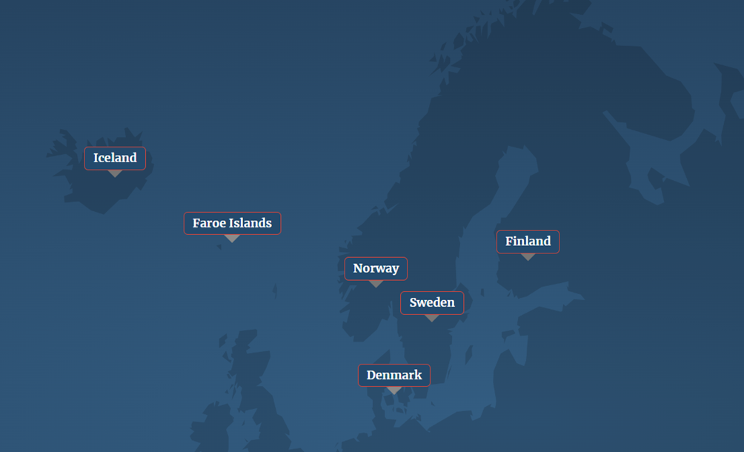

Nordic Road Association (NVF)

NVF is a public-private co-operation with over 300 member organizations in the Nordic countries.

NVF’s vision is competence without borders. NVF aims to exchange information, knowledge, experience, and best practices among the Nordic countries.

This is done in the NVF working groups through Nordic specialist co-operation.

NVF works in four-year-periods. In the current period 2024–2028, the strategic basis for the work is the UN Sustainable Development Goals (SDGs).

NVF has national associations in Denmark, Iceland, the Faroe Islands, Finland, Norway and Sweden.

The chairmanship of the NVF is changed on a rotating basis every four years. Finland holds the chairmanship for the period 2024–2028.

Nordic Road Association NVF / PTL ry

c/o Väylävirasto

Yliopistonkatu 38

33100 Tampere

Finland

[nvf@vayla.fi](mailto:nvf@vayla.fi)

|  |  |
| --- | --- |
|  |  |