Version 21.6.2023

Program for NVF Road technology Annual meeting
21th -23th of August 2023
Conference hotel Hanasaari, Espoo, Finland

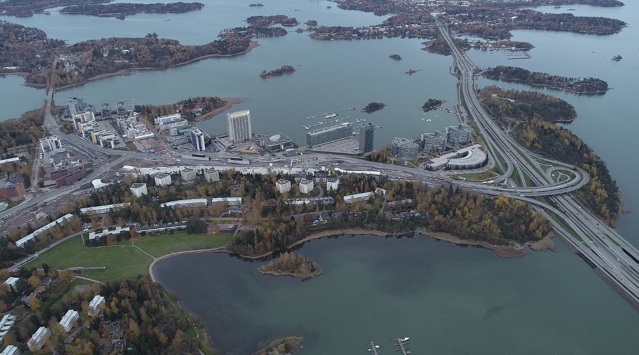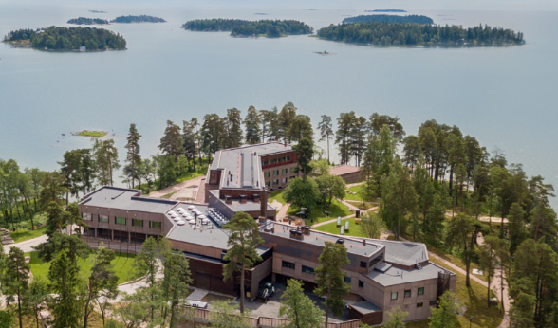
Program for NVF Road technology Annual meeting 2023
Time | Monday 21 August
19:00 | Registration  Get together  Conference hotel Hanasaari, Espoo, Finland
 | Tuesday 22 August
 | Registration, coffee
08:30 | Opening of the seminar  Anders Östergård/ NTM-centralen i Österbotten
08:45 | Norway, 25 min  Maximum water content in Norwegian coarse granular road construction materials - Head of Road Technology Kjell Arne Skoglund/Statens vegvesen
09:15 | Denmark, 25 min  “Asphalt reinforcement. What is it and what are the advantages: longer lifespan, less use of raw materials, less disturbance of traffic. incl. update on development of software for dimensioning.” – Head of Projects Jens Adamsen S&P Reinforcement Nordic  BSM Bitumen Stabiliseret Materiale - Projektchef for asfalt og afdelingschef for BSM Allan Bay - Arkil
09:45 | Coffee break
10:00 | Sweden, 25 min
10:30 | Finland, 25 min  Infrastructure management system as a supporting tool in lowering CO2 emissions - real-time data supported planning of maintenance activities, optimal use of resources and improved logistics in road construction contracts – R&D Lead Michalina Makowska/Ramboll
11:00 | Break
11:15 | Iceland, 25 min  Geothermal activity and roads - Head of Geology and Road Technology Birkir Hrafn Jóakimsson/ Icelandic Road and Coastal Administration
11:45 | Faroe Islands , 25 min  The challenge of maintaining and expanding the road system in a remote and small community  - Dávur Johannesen and Ási Mikkelsen/Landsverk
12:15 | Lunch
13:30 | Researcher competition  Participants from all countries 20 min  - DK: Line Kloster Pedersen/Visibuilt ApS: ”A paradigm shift in biobased asphalt binders”  - FI: Fan Zhang/Aalto University: ”Microwave Maintenance of Asphalt Pavement containing Steel Slag for Self-healing”  - NO: Hoa Chen (Ph.D.): “Laboratory-based Modelling of Viscoelastic Properties of Asphalt Pavements”  - SE: Julian Rodriguez (PhD student at KTH (Royal Institute of Technology): “Digital twin for future maintenance planning: Norvik Port Sweden case study”
15:00 | Coffee break with voting
15:30 | Workshop
19:00 | Dinner
 |  | Wednesday 23 August
 |  | Check out from the Hotel
09:00 |  | Technical tour with bus in Espoo-Helsinki Area
12:00 |  | Lunch
13:00 |  | End of seminar

Conference venue: https://www.hanaholmen.fi/en/
https://www.hanaholmen.fi/sv/

Registration fee includes:
- Hotel room 150 eur/night – 2 nights = 300 eur
- Conference facilities, transportation,
coffees, lunches, dinner = 200 eur
Package = 500 eur

Participation via teams (Tuesday 22th August) will be also available.

Registration options and fees:
- Full Package 500 EUR

- Package without hotel room 200 EUR

- Teams participation 0 EUR

Registration link:
https://ssl.eventilla.com/roadtechnology

Deadline for registration is in June 28.6.2023

Please contact mikko.leppanen@ramboll.fi for any questions etc.

